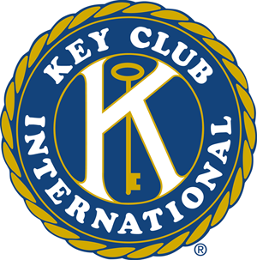


Most students would prefer to sleep in on their first day off from school…but not Key Club members! Kiwanis Peanut Day called for many volunteers to collect money for Kiwanis’s local charities. Key Club members did an amazing job collecting money for nine hours, from 7AM until 4 PM! Great job guys!
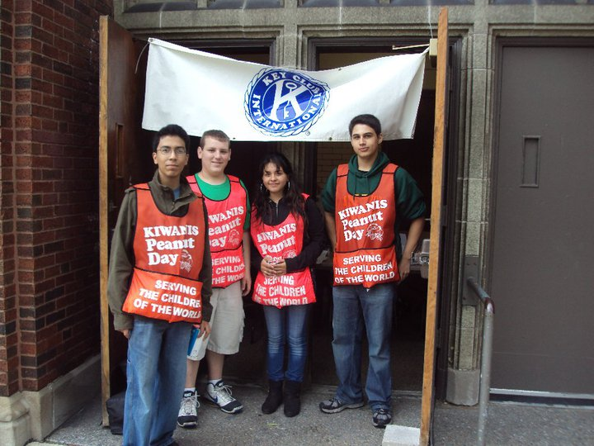

leadership.
International boasts a membership of more than 12,000 members on more than 525 campuses around the globe.
Circle K International is comprised of college and university students who are responsible citizens and leaders with a lifelong commitment to community service worldwide. As a collegiate organization, Circle K International holds the promise of today’s student becoming tomorrow’s leader. It exists to meet the personal needs of the individual collegian through the qualities of leadership, the rewards of service, and the unique spirit of friendship. Leadership, service and fellowship; the embodiment of the three tenets premier collegiate service organization. A member of the Kiwanis family, Circle K International boasts a membership of more than 12,000 members on more than 525 campuses around the globe.
Circle K International is comprised of college and university students who are responsible citizens and leaders with a lifelong commitment to community service worldwide. As a collegiate organization, Circle K International holds the promise of today’s student becoming tomorrow’s leader. It exists to meet the personal needs of the individual collegian through the qualities of leadership, the rewards of service, and the unique spirit of friendship. Leadership, service and fellowship; the embodiment of the three tenets of Circle K International are necessary to shape the future, realized in the colleges and universities of today.
Circle K International is the world’s premier collegiate service organization. A member of the Kiwanis family, Circle K International boasts a membership of more than 12,000 members on more than 525 campuses around the globe.
Circle K International is comprised of college and university students who are responsible citizens and leaders with a lifelong commitment to community service worldwide. As a collegiate organization, Circle K International holds the promise of today’s student becoming tomorrow’s leader. It exists to meet the personal needs of the individual collegian through the qualities of leadership, the rewards of service, and the unique spirit of friendship. Leadership, service and fellowship; the embodiment of the three tenets

In this issue….
- Kiwanis Peanut Day……1
- Elvis is Alive 5K Race……2
- Spare Change Save Babies…3
- Reminders…………...3
“Unselfish & noble actions are the most radiant pages in the biography of souls”
-David Thomas

First Meeting: October 6th at 7:10 AM! 1
Key Club is Making Me Nuts!

Official Newsletter of Lane Tech Key Club
August/September 2010

K E Y C L U B
Maggie’s Musings

Elvis is Alive!
Just Kidding!

Isn’t it always extremely fun to see impersonators of Elvis? It’s intriguing and fun to watch. Key Club had the opportunity to witness such entertainment in August while volunteering at the “Elvis is Alive” 5K. Race.
Key Club performed its usual duties of setting up for the event, passing out water, and encouraging racers to compete the run! Keep up the good work!
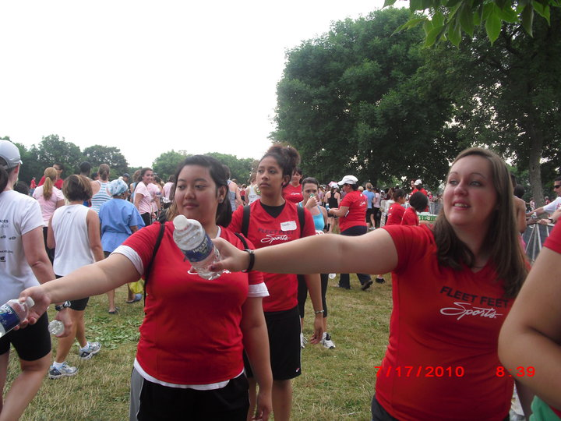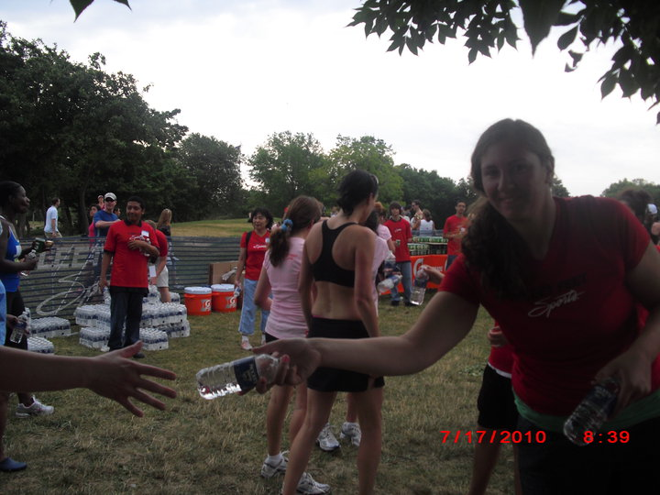
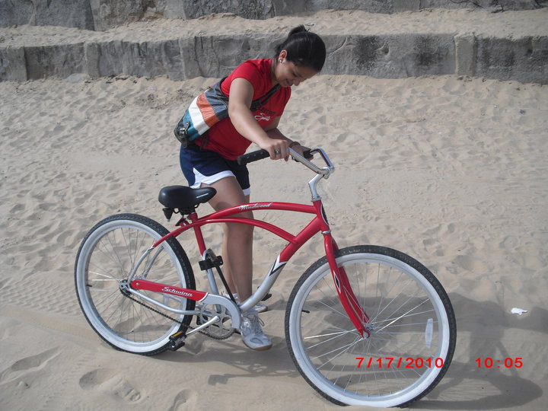

Officers: RTC’s October 3rd at Hinsdale High School! 2
Officers!
RTC’s are taking place at Hinsdale High School October 3rd at 12:30 PM.
First LT Key Club Meeting:
October 6th @ 7:10 AM

Meet in the lunchroom. We will take you to the auditorium!


The Woman’s Center in Des Plaines, Illinois is a non-profit pro-life crisis pregnancy center. They help thousands of women, providing them with compassionate counseling and material assistance. They appreciate all of our support. Thus, I (Magdalena) am providing baby bottles to which you can put in your spare change for three weeks, until October 21st. I will be dropping off these bottles at The Women’s Center in Des Plaines on the 23rd of October. If you are interested please e-mail me (mmastalerz93@gmail.com) or via cell phone (1-773-677-2011). Thank You!

Spare Change
Saves Babies!
Reminders!

CONTACT US…
- E-Mail: lt_key_club@yahoo.com

- Website: lanetechkeyclub.yolasite.com

- Facebook & Twitter: Lane Tech Key Club

K E Y C L U B
The Lane Tech Key Club Official Newsletter 3

